# 2019 XDJ-XZ v6.1.4 - mapping for Traktor Pro 3+2 - DJ Estrela

**HOW TO DOWNLOAD:** you can ONLY download the mapping if you register and verify your email in the DJTT site!

FEATURE LIST:

* 7x Jogwheel FX chains
* 5x TP3 MixerFX
* 11x MacroFX
* 21x padFX (“instant gratification”)
* 4x Rolls modes
* Reverse Flux
* Beatjump controls

LINKS:

* **Download Link**: <https://maps.djtechtools.com/mappings/10305>
* **Video demo**: <https://youtu.be/7EPfY9bGGlw>

DOCUMENTATION IN THE ZIP FILE:

* **Quick overview**: [8x slides](https://github.com/pestrela/music_scripts/blob/master/traktor/mapping_ddj_sx2_sz1/DDJ-SX2%20and%20SZ%20-%20v6.1.1%20TP3_TP2%20-%20Quick%20Overview.pdf)
* **Installation guide**: [3x pages](https://github.com/pestrela/music_scripts/blob/master/traktor/mapping_ddj_sx2_sz1/Installation%20Help/DDJ-SZ1%20-%20Installation%20(Official%20Pioneer)%20-%20Use%20as%20a%20Reference%20for%20EXTERNAL%20controllers.pdf)
* **Detailed manual**: [14x pages](https://github.com/pestrela/music_scripts/blob/master/traktor/mapping_ddj_sx2_sz1/DDJ-SX2%20and%20SZ%20-%20v6.1.1%20TP3_TP2%20-%20Full%20Manual.pdf)
* **Demo Video**: [between 5..30 minutes](https://www.youtube.com/watch?v=H_TE2mtuM6Q&list=PLIlvTGzSxI0V3SUnYFYq4hpeu0o_XyP2l)

ABOUT THIS MAPPING:

* This a 2019 mapping for the XDJ-XZ. It works on both Traktor 3 and 2. The mapping was based on my previous mapping for the DDJ-SZ/SRT.
* It is also the most complete by far. It supports TP3 MixerFX, MacroFX, JogFX chains, padFX, Rolls, Slip reverse. Be sure to see the documentation for all the features.
* If you have ANY problems please raise it in the comments section. Do not disrespect the ridiculous time people spend building complex mappings by pressing a thumb down without leaving any steps to reproduce the issue.
* All my mappings are a free gift to the community, to enable DJs to use their preferred Software with their preferred. If you want further appreciation, PayPal / Patreon donations are welcome ([pedro.estrela@gmail.com](mailto:pedro.estrela@gmail.com) / <https://www.patreon.com/djestrela>)

INSTALLATION INSTRUCTIONS:

* Please see the pdf in the “install” folder, and also use the DDJ-1000 pdfs as a reference.
* DO NOT SET XDJ-XZ in the controller manager!

V6.1.3 XDJ-XZ Demo: <https://youtu.be/7EPfY9bGGlw>

* 0:14 Hot Cues / Loop Rolls / Remix decks
* 0:37 11x TP2 MacroFX / 5x TP3 MixerFX / 6x Pioneer ColorFX
* 1:29 27x PadFX /
* 2:01 MIDI scratch
* 2:07 7x JogFX
* 2:32 Loops

V6.0.0 Features / Demo: (first release): <http://youtu.be/H_TE2mtuM6Q>

* 2:10 MacroFX usage (similar to Pioneer ColorFX): Wormhole, Polarwind, Flighttest, LaserSlicer
* 3:45 How to use both Traktor MacroFx and Pioneer ColorFX
* 4:07 Pioneer-style Beat FX, controlled on the lower right corner of the mixer: Echo, Flanger, Reverb
* 5:27 Sub-pages to access all MacroFX
* 7:07 Jogwhell_FX usage demo (seven different chains of 3x effects - very powerful)
* 2:10 MacroFX usage (similar to Pioneer ColorFX): Wormhole, Polarwind, Flighttest, LaserSlicer
* 3:45 How to use both Traktor MacroFx and Pioneer ColorFX
* 4:07 Pioneer-style Beat FX, controlled on the lower right corner of the mixer: Echo, Flanger, Reverb
* 5:27 Sub-pages to access all MacroFX
* 7:07 Jogwhell_FX usage demo (seven different chains of 3x effects - very powerful) [*]
* 9:09 Pressing hotcue now cancels JogwheelFX back into scratch mode
* 9:43 Roll demo [*]
* 10:00 PadFX with 3x subpages [*]
* 10:48 Slicer demo [*]
* 11:05 Second "shift" button (pressing deck number itself)
* 11:50 Waveform zoom +- and Zoom default [*]
* 12:20 Autoloop is always 4x beats - this avoids mistakes!
* 13:20 Beatjump now uses the second shift button
* 15:20 Correcting a wrong loop for just 1x beat
* 17:00 Moving a 4-beat loop for 16x beats
* 18:00 The Sync button now operates like Hotcue. This is useful for TempoSync operation
* 19:40 Key adjustment is now disabled
* 00:00 Tempo range now goes in smll steps (6% / 10% / 16% / 100%) (not shown on video)
* 00:00 shift+tempo = forces changing tempo, ignoring sync value (not shown on video)

XDJ-XZ Overview:

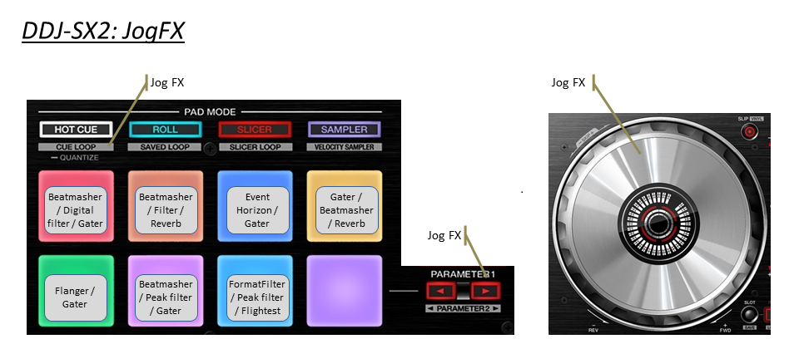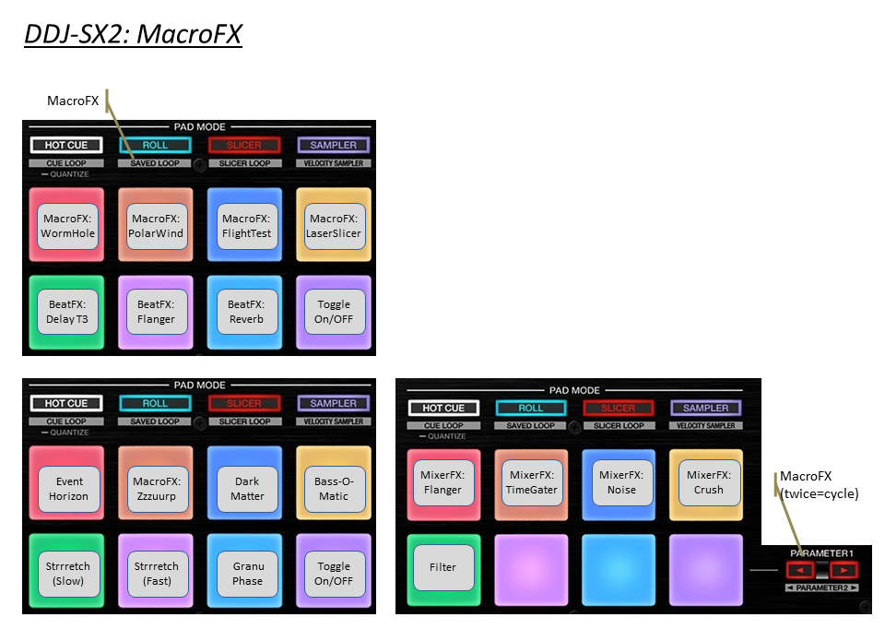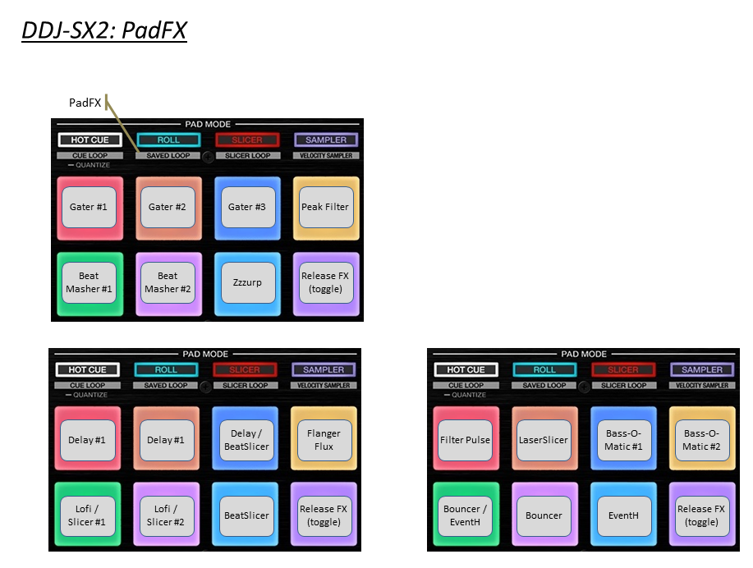

|  |  |  |  |
| --- | --- | --- | --- |
|  |  |  |  |
|  | Section DECK |  |  |
| Hardware (DDJ-SZ) | Main Function | +Shift | +Deck 1/2/3/4 Shift |
| CENSOR / | TP3 Reverse Flux | Reverse |  |
| DECK (1/2/3/4) | Select Deck 1-4 | Deck Flavor |  |
| JOG (platter ) | Scratch / Pitch Bend | Quick Search | *(see also grid section)* |
| JOG (wheel side) | Pitch Bend |  |  |
| KEYLOCK | KeyLock Toggle | Tempo Range (6/10/16/100) |  |
| KEY LOCK long | KeyLock (Preserve Pitch) |  |  |
| NEEDLE SEARCH | SEARCH (if paused) | NEEDLE SEARCH |  |
|  |  |  |  |
|  |  |  |  |
| PLAY | Play/Pause | Vinyl Stop |  |
| CUE | Cue | Track Begin |  |
| SYNC | Sync Force | Sync Off | Set as tempo Master |
| SLIP / VINYL | Flux Mode On/Off | Scratch On/Off |  |
| TEMPO | Tempo Control | Tempo Control (No sync) |  |
|  |  |  |  |
|  |  |  |  |
|  | Section BROWSER |  |  |
| Hardware (DDJ-SZ) | Main Function | +Shift | +Deck 1/2/3/4 Shift |
| Turn Browser Knob | Scroll List | Scroll Tree | WaveForm Zoom Adjust |
| Push Browser Knob |  | Open / close Folder | WaveForm Zoom Auto |
| LOAD | Load | Unload |  |
| BACK | Browser Only (Toggle) | Scroll Favorites |  |
| PANEL SELECT | Select Layout | View Full screen |  |
|  |  |  |  |
|  | Section LOAD PREPARE |  |  |
| Hardware (DDJ-SZ) | +Load Prepare | + SHIFT |  |
| LOAD PREPARE |  | Preparation List |  |
| Push Browser | Add to Preparation List |  |  |
| Push BACK | Remove from the list |  |  |
|  |  |  |  |
|  |  |  |  |
|  | Section GRID |  |  |
| Hardware (DDJ-SZ) | + GRID Adjust | + GRID Slide | +Shift |
| Turn Jog Wheel | BPM +/- | Move Grid |  |
| Turn BROWSER | BPM +/- [ FINE ] | Move Grid [ FINE ] |  |
| Push BROWSER | BPM AUTO | SLIDE AUTO |  |
| GRID SLIDE + ADJUST | Auto Grid Marker |  |  |
| GRID ADJUST |  |  | Set Grid Marker |
| GRID SLIDE |  |  | Delete Grid Marker |
|  |  |  |  |
|  |  |  |  |
|  | Section LOOP |  |  |
| Hardware (DDJ-SZ) | Main Function | +Shift | +Deck 1/2/3/4 Shift |
| AUTO LOOP | 4-Beat loop | *-* | Select Move 1-beat |
| AUTO LOOP +Shift | Set Loop (req. size) | *-* | Loop active |
| 1/2X | Select Loop 1/2X | Select Move 1/2X | BeatJump / Loop Move |
| 2X | Select Loop 2X | Select Move 2X | BeatJump / Loop Move |
| IN | Loop IN | Capture Loop (remix deck) |  |
| OUT | Loop OUT | Delete Loop (remix deck) |  |
|  |  |  |  |

|  |  |  |
| --- | --- | --- |
|  |  |  |
|  | Section FLIP |  |
| Button FX 3 | Main Function | +Shift |
| FLIP SLOT | Loop Recorder Select Size |  |
| FLIC REC | Loop Recorder Record | Loop Recorder Undo/Redo |
| FLIP START | Loop Recorder Play/Stop | Loop Recorder Clear |
|  |  |  |
|  |  |  |
|  | Section MIXER |  |
| Hardware (DDJ-SZ) | Main Function | +Shift |
| MASTER LEVEL | Volume Master Out |  |
| MASTER CUE | MASTER CUE |  |
| BOOTH LEVEL | Volume Booth Out |  |
| TRIM | Gain |  |
| HI | Hi |  |
| MID | Mid |  |
| LOW | Low |  |
| CUE MONITORING | Monitoring | Echo Out Type (1/2/3/4) |
| CH FADER | Channel Fader | CH Fader Start |
| CROSSFADER | Crossfader |  |
| INPUT SELECT | Input select |  |
| CROSS F. CURVE | Crossfader Curve |  |
| USB A & B | USB A & B | Unload Deck |
|  |  |  |
|  |  |  |
|  | Section JOG_FX  and Beat_FX |  |
| Hardware (DDJ-SZ) | Main Function | +Shift |
| FILTER | Macro FX |  |
| SAMPLER VOLUME | BestFX DRY/WET |  |
|  |  |  |
|  |  |  |
|  | section FX Unit1+2 |  |
| Hardware (DDJ-SZ) | Main Function | +Shift |
| Knob Fx 1 | Knob Fx 1 |  |
| Knob Fx 2 | Knob Fx 2 |  |
| Knob Fx 3 | Knob Fx 3 |  |
| BEATS rotate | Dry/Wet | Traktor Master volume |
| BEATS press | Toogle all FX Units | Record (FX2 only) |
| Button FX 1 | FX 1 on | Select FX 1 |
| Button FX 2 | FX 2 on | Select FX 2 |
| Button FX 3 | FX 3 on | Select FX 3 |
| TAP | Turn all FX off |  |
|  |  |  |
|  |  |  |
|  | section HOTCUE |  |
| Hardware (DDJ-SZ) | Main Function | +Shift |
| PAD 1 | Hotcue 1 | Delete Hotcue |
| PAD 2 | Hotcue 2 | Delete Hotcue |
| PAD 3 | Hotcue 3 | Delete Hotcue |
| PAD 4 | Hotcue 4 | Delete Hotcue |
| PAD 5 | Hotcue 5 | Delete Hotcue |
| PAD 6 | Hotcue 6 | Delete Hotcue |
| PAD 7 | Hotcue 7 | Delete Hotcue |
| PAD 8 | Hotcue 8 | Delete Hotcue |
| HOTCUE [Long Press] | Hotcue Type Mode (TBD) |  |
| PARAMETER < | MACRO FX shortcut | PITCH -0,01 |
| PARAMETER > | JOG FX shortcut | PITCH +0,01 |
|  |  |  |
|  | section ROLL |  |
| Hardware (DDJ-SZ) | Main Function | +Shift |
| PAD 1 | Roll ''1/16 | Forward Roll |
| PAD 2 | Roll ''1/8 | Backward Roll |
| PAD 3 | Roll ''1/4 | Loop toogle |
| PAD 4 | Roll ''1/2 | Beatjump |
| PAD 5 | Roll ''1 |  |
| PAD 6 | Roll ''2 |  |
| PAD 7 | Beatjump - (slip) |  |
| PAD 8 | Beatjump + (slip) |  |
| PARAMETER < | MACRO FX shortcut |  |
| PARAMETER > | JOG FX shortcut |  |
|  |  |  |
|  |  |  |
|  | section SLICER |  |
| Hardware (DDJ-SZ) | Main Function | +Shift |
| PAD 1 | Slicer #1 | 8 beats |
| PAD 2 | Slicer #2 | 16 beats odd |
| PAD 3 | Slicer #3 | 16 beats even |
| PAD 4 | Slicer #4 |  |
| PAD 5 | Slicer #5 |  |
| PAD 6 | Slicer #6 |  |
| PAD 7 | Slicer #7 |  |
| PAD 8 | Slicer #8 |  |
| PARAMETER < | MACRO FX shortcut |  |
| PARAMETER > | JOG FX shortcut |  |
|  |  |  |
|  |  |  |
|  | section SAMPLER  / VELOCITY SAMPLER |  |
| Hardware (DDJ-SZ) | Main Function | +Shift |
| PAD 1 | Cell #1 / #9 | Column #1 Mute |
| PAD 2 | Cell #2 / #10 | Column #2 Mute |
| PAD 3 | Cell #3 / #11 | Column #3 Mute |
| PAD 4 | Cell #4 / #12 | Column #4 Mute |
| PAD 5 | Cell #5 / #13 | Column #1 Loop / 1-shot |
| PAD 6 | Cell #6 / #14 | Column #2 Loop / 1-shot |
| PAD 7 | Cell #7 / #15 | Column #3 Loop / 1-shot |
| PAD 8 | Cell #8 / #16 | Column #4 Loop / 1-shot |
| PARAMETER < | Pad 1 to 8 | Page - |
| PARAMETER > | Pad 9 to 16 | Page + |
|  |  |  |
|  |  |  |
|  | section CUE LOOP  = MACRO FX |  |
| Hardware (DDJ-SZ) | Main Function | +Shift |
| PAD 1 | MacroFX: WormWhole | MACRO FX page 1 |
| PAD 2 | MacroFX: PolarWind | MIXER FX |
| PAD 3 | MacroFX: FlightTest | MACRO FX page 2 |
| PAD 4 | MacroFX: LaserSlicer |  |
| PAD 5 | BeatFX: Delay T3 |  |
| PAD 6 | BeatFX: Flanger |  |
| PAD 7 | BeatFX: Reverb |  |
| PAD 8 | Toggle On/OFF |  |
|  |  |  |
| PAD 1 | MixerFX: Flanger | MACRO FX page 1 |
| PAD 2 | MixerFX: TimeGater | MIXER FX |
| PAD 3 | MixerFX: Noise | MACRO FX page 2 |
| PAD 4 | MixerFX: Crush |  |
| PAD 5 | Filter |  |
| PAD 6 |  |  |
| PAD 7 |  |  |
| PAD 8 | Toggle On/OFF |  |
|  |  |  |
| PAD 1 | MacroFX: FlightTest | MACRO FX page 1 |
| PAD 2 | Strrretch (Slow) | MIXER FX |
| PAD 3 | Strrretch (Fast) | MACRO FX page 2 |
| PAD 4 | DarkMatter |  |
| PAD 5 | MixerFX: Flanger |  |
| PAD 6 | MacroFX: FlightTest |  |
| PAD 7 | MacroFX: LaserSlicer |  |
| PAD 8 | Toggle On/OFF |  |
| PARAMETER < | MACRO FX shortcut |  |
| PARAMETER > | JOG FX shortcut |  |
|  |  |  |
|  |  |  |
|  | section SAVED LOOP  = PAD FX |  |
| Hardware (DDJ-SZ) | Main Function | +Shift |
| PAD 1 | Gater #1 | PAD FX page 1 |
| PAD 2 | Gater #2 | PAD FX page 2 |
| PAD 3 | Gater #3 | PAD FX page 3 |
| PAD 4 | Peak Filter |  |
| PAD 5 | Beatmasher #1 |  |
| PAD 6 | Beatmasher #2 |  |
| PAD 7 | Zzzurp |  |
| PAD 8 | Release FX (toggle) |  |
|  |  |  |
| PAD 1 | Delay #1 | PAD FX page 1 |
| PAD 2 | Delay #2 | PAD FX page 2 |
| PAD 3 | Delay / BeatSlicer | PAD FX page 3 |
| PAD 4 | Flanger Flux |  |
| PAD 5 | DigitalLofi / BeatSlicer #1 |  |
| PAD 6 | DigitalLofi / BeatSlicer #2 |  |
| PAD 7 | BeatSlicer |  |
| PAD 8 | Release FX (toggle) |  |
|  |  |  |
| PAD 1 | EventHorizon | PAD FX page 1 |
| PAD 2 | Zzzurp | PAD FX page 2 |
| PAD 3 | DarkMatter | PAD FX page 3 |
| PAD 4 | BassOMatic |  |
| PAD 5 | Strrretch (Fast) |  |
| PAD 6 | Strrretch (Slow) |  |
| PAD 7 | GranuPhase |  |
| PAD 8 | Release FX (toggle) |  |
| PARAMETER < | MACRO FX shortcut |  |
| PARAMETER > | JOG FX shortcut |  |
|  |  |  |
|  |  |  |
|  | section SLICER LOOP  = JOG FX |  |
| Hardware (DDJ-SZ) | Main Function | +Shift |
| PAD 1 | Beatmasher / Digital filter / Gater |  |
| PAD 2 | Beatmasher / Filter / Reverb |  |
| PAD 3 | Eventhorizon / Filter / Gater |  |
| PAD 4 | Gater / Beatmasher / Reverb |  |
| PAD 5 | Flanger / Filter / Gater |  |
| PAD 6 | Beatmasher / Peak filter / Gater |  |
| PAD 7 | FormatFilter / Peak filter / Flightest |  |
| PAD 8 | Release FX (toggle) |  |
| PARAMETER < | MACRO FX shortcut |  |
| PARAMETER > | JOG FX shortcut |  |
|  |  |  |
|  |  |  |